Pitt Data to Emory Format

**Creating SQL scripts to create the raw data from Pitt data.**

1. **BED LOCATION**

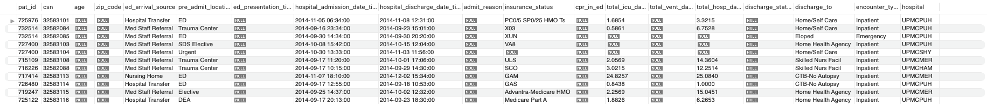

1. **ENCOUNTER**

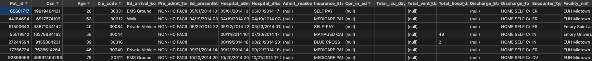

1. **NON_INFUSED MEDS**

I am looking into the medication table in the hidenic15raw schema. Distinct routes will tell us which ones are infusion meds and which ones are non-infused.

1. **VITALS**

1. **LABSTable

   Description automatically generated**
2. **SENSITIVITIESTable

   Description automatically generated**

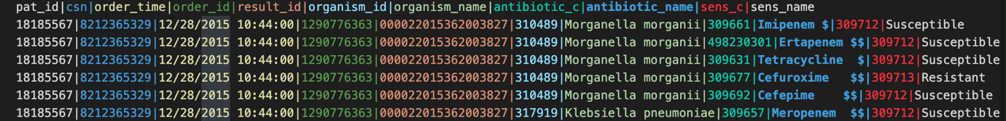

1. **DIAGNOSIS**
2. **DEMOGRAPHICS**

1. **ICDPROCEDURES**
2. **VENT**
3. **GCS**

1. **CPT**
2. **CULTURES**
3. **INFUSEDMEDS**

1. **ORPROCEDURES**

